Ashley Chan IST Website –

# Outline of the Purpose of this website, and the intended Audience –

The purpose of the Project Inspire website is to publicise a company called Project Inspire, which is an educational institute that is hired by schools and companies alike to come into their institutes and teach STEM in new, fun and inventive ways to reach the audience at hand. This website is purely informative, and writes about the aims, goals what the business does, and a run down of the programs that it holds, who it markets to and how to get in contact with them.

The targeted audience for this website would be professional institutes, mainly schools, as the programs run by Project Inspire are directed towards both Teachers and Students. Due to this, the website had to have a “professional front”, as businesses such as schools would only trust and hire professionals in their fields of study, which explains some of the design choices, such as the structured fonts which are easily readable but look standard, and darker, more mature coloured website – using colours such as a dark blue, navy blue, and variants of grey and white translucent backgrounds.

# Screenshot with annotations –

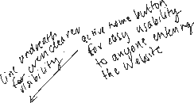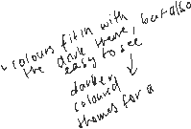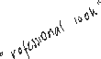

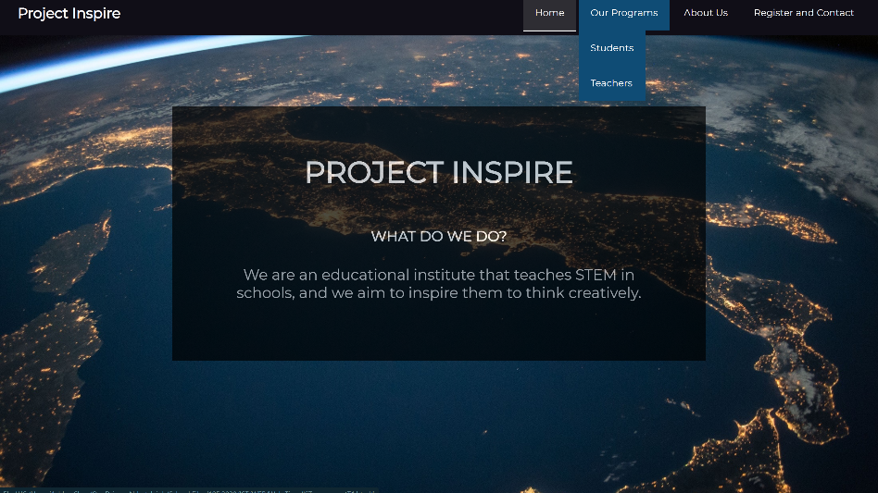s

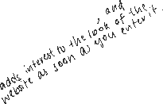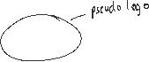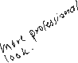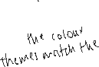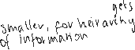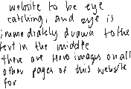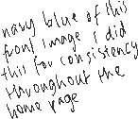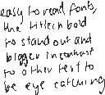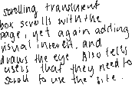

# 

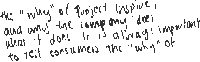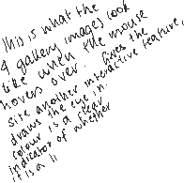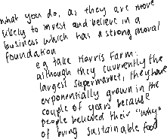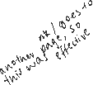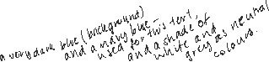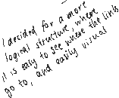

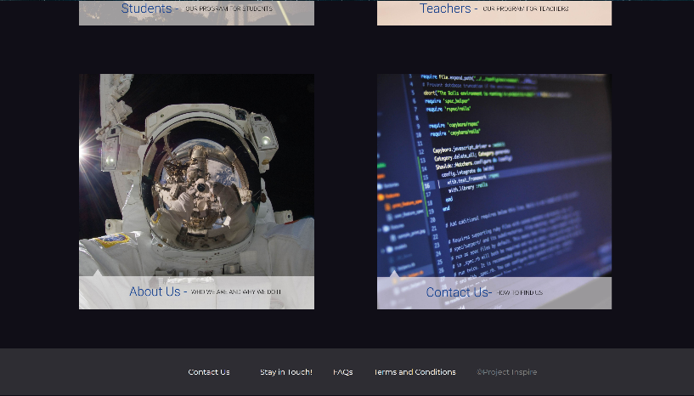

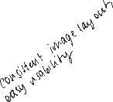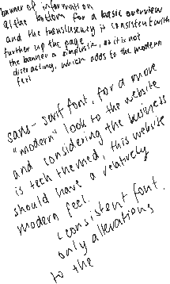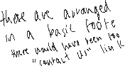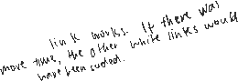

# List of Media Used –



N.B all media used was taken from pexels.com, where the licensing for the images is free to use for both commercial and non commercial purposes.

# IST references -

https://www.pexels.com/photo/astronomy-atmosphere-earth-exploration-220201/

https://www.pexels.com/photo/woman-writing-on-a-whiteboard-3862130/

https://www.pexels.com/photo/flight-sky-earth-space-2166/

https://www.pexels.com/photo/woman-studying-moon-surface-3862613/

https://www.pexels.com/photo/burning-dangerous-dark-exploration-355938/

https://www.pexels.com/photo/blur-close-up-code-computer-546819/

https://www.pexels.com/photo/closeup-photo-of-black-and-blue-keyboard-1194713/

https://www.pexels.com/photo/apps-blur-button-close-up-267350/

https://www.pexels.com/photo/black-telescope-under-blue-and-blacksky-2034892/

https://www.pexels.com/photo/astronaut-33684/

https://www.pexels.com/photo/black-and-gray-laptop-computer-turned-on-doing-computer-codes-181271/

https://www.pexels.com/photo/black-illustration-on-white-printer-paper-716661/

https://www.pexels.com/photo/3d-design-on-laptop-screen-3913016/